The orbit files

Welcome to this document where we expose the owner of orbit for hosting, possessing, distributing cheese pizza in an unblocking discord server.

What is orbit? Orbit is an unblocked game site that features your typical unblocked game site features and once had two links in total. But there is a dark secret with the owner that he doesn't want people to know about so let's dive in.

First off, orbit had a mysterious hacking recently and the site was updated to have cheese pizza in one the links that I will censor. Nobody knows who hacked the site but rumor has it that the owner of orbit did this and they're trying to censor people for talking about it. In a deleted message from the orbit discord server, ojthedev, the owner of orbit, said that he will kick people from the server for talking about the cheese pizza problem and this is an example of silencing people.

Furthermore, ojthedev has been caught lying to their users about the “hacking” of the website saying that he quote on quote “he didn't update the site like this, it was the hacker who hacked the domain”. Here is proof saying something like this.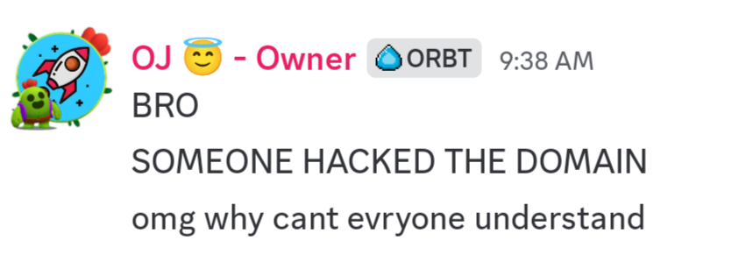

He's even trying to claim that he doesn't own the censored domain anymore. In another message, ojthedev claims he doesn't own the censored domain and his other orbit link known as edubase.nekoweb.org is his main link. Here's proof of him saying something like this.

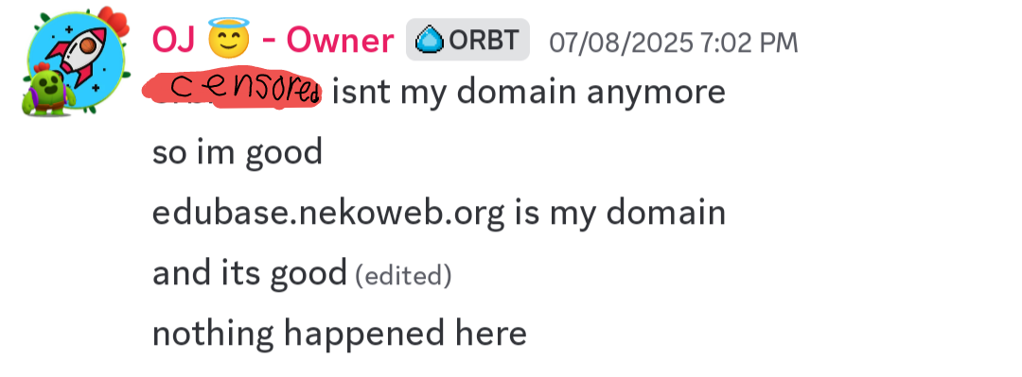

During the time of the document's existence, Craz, the creator of the website known as cvm.rest, has come out about the situation with a quote from the website known as wilway.today. Cruz said “I am NOT apart of Orbit anymore.

I deleted the domain on FreeDNS (https://freedns.afraid.org/), and someone TOOK that domain and now has an indefinitely loading page as I am typing this (7/11/25).

Before this, the domain was just had a black background with text (unfortunately, there is no archive of "orbit.nekoweb.org") that blended into the page, basically an iframe.

The one IP to the domain was GitHub Pages (185.199.111.153)”. Also, ojthedev has blocked craz according to the orbit drama text file on the wilway website proving the ojthedev likes to silence people despite them telling the truth.

While the owner of orbit kinda no longer owns the censored domain, the owner of orbit tried to slander me for quote on quote “scamming people” when literally he might be the one to blame for the toxicity and weirdness. Here's a screenshot of an ad for orbit in the vplaza discord’s self promo channel. I had to rescreenshot it because I deleted the uncensored version for legal reasons.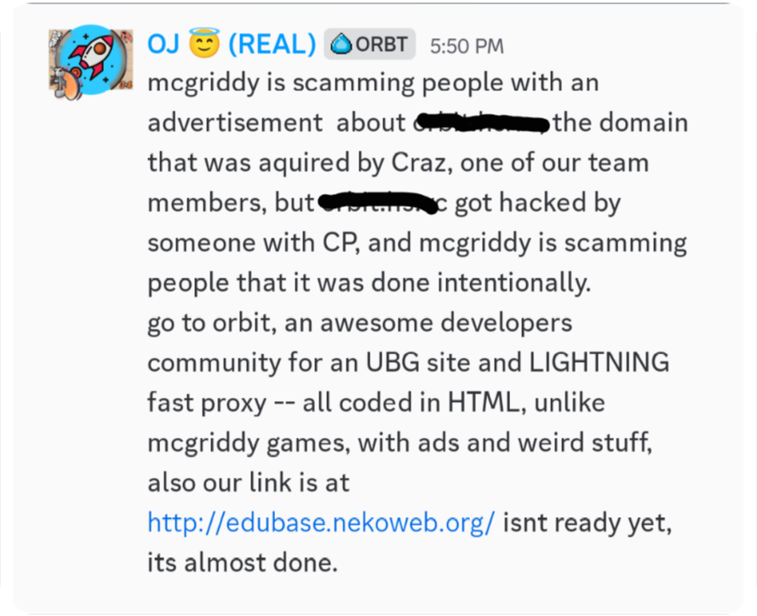

First of all, he thinks that my site has weird stuff in it which is insane because my site is just normal and the ads claim is making me question this guy's thoughts. My site has games that might contain ads but there are many games that don't have ads anyways plus orbit has way less games than my site. This is mostly false advertising because orbit doesn't have much features and they say that the site is almost done but nekoweb in its free tier only brings in 500mb in storage which is not enough for many game sites. Even if ojthedev bought a monthly subscription or donation to nekoweb, nekoweb would most likely not allow proxies since proxy sites are expensive to host, especially the unblocked game site ones making this unblocked unhostable on nekoweb.

While this is the tip of the iceberg, what I will say next is going to make you lose hope for this site. Oj the dev is trying to silence people with false DMCA takedowns to anyone who talks about this situation. Ojthedev has tried to silence me and craz using DMCA takedowns which is straight up illegal. On craz’s DMS, ojthedev is trying to make craz remove the orbit drama text file off his website or his site will be taken down and he lies to him saying that it was his fault which is absurd. Here's the screenshot from craz’s DMS.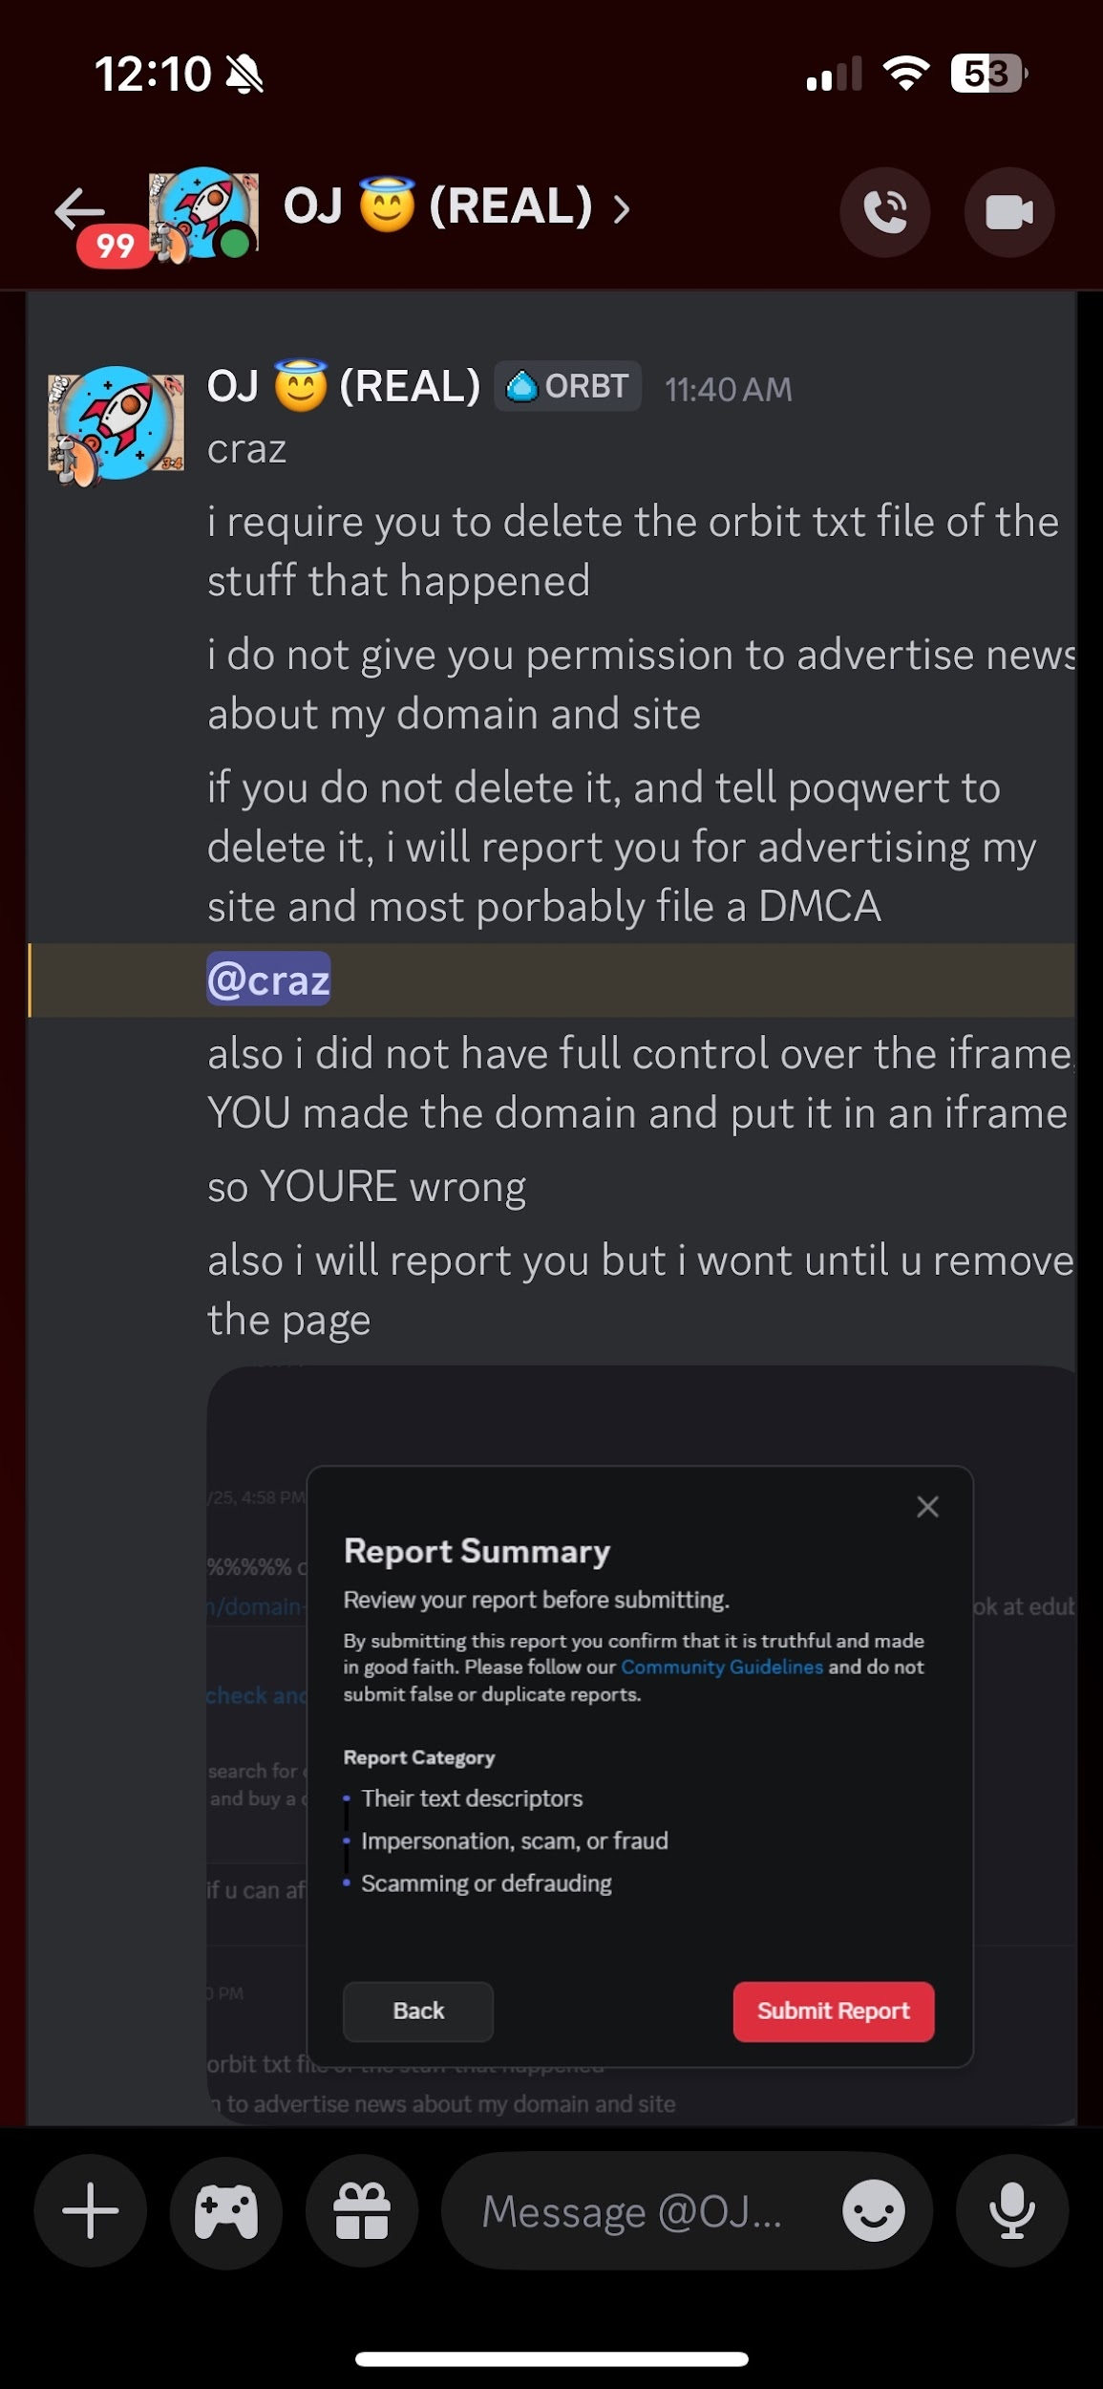

The funny part about this is that ojthedev doesn't even own the copyright for orbit. Also did you know that orbit is infringing on copyright for its site name, let me explain. So the site known as edubase.nekoweb.org is trying to impersonate the site known as edubase which is an education website used in schools and edubase is protected by copyright and trademarks. Orbit is basically infringing on those copyrights and trademarks edubase had for the site's name by making a non educational website on a platform that's non educational filled with broken games and webpages.

Ojthedev is basically the duckumentaries of unblocked game sites. Now what is duckumentaries anyways? Duckumentaries is Roblox drama YouTuber that is involved with controversy surrounding copyright infringement, silencing people using false copyright strikes, and the whole operation having bad actors in it. If you want to learn more about duckumentaries then I suggest you watch these three YouTube videos about it.

Here are the links to the videos

<https://youtu.be/EubycpRbP1w?si=4iCjRJaBuDm_kBGe>

<https://youtu.be/YUTfr5_nRF0?si=jzIZ2jXt84zkOGA0>

<https://youtu.be/Xk3cozuH0GU?si=WFspw0M-JwQ4LfII>

At this point Oj should not make an unblocked game site he should be held accountable for his actions.

Stay tuned for more updates